Document Based Databased

Matas Orliukas : R246824

Part 1:

1. I create the bank database with the collection clients. I then insert all documents found in the json file, I then attempted to insert the given document.

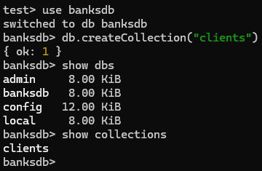

1. Margie’s profile was added because by default MongoDB doesn’t check any attributes for duplicity. To fix this I can create an index on emails so that when something is added it uses the attribute email to check for duplicity. If I try to insert Margie again an error occurs because the email is the same.

1. I updated the balance applying an interest to all active young female clients who are below the age of 30.

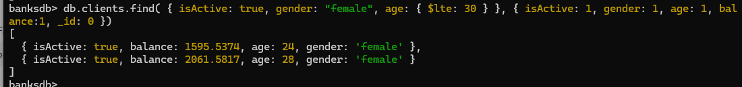

1. I added the common hobbies of reading and video games and the favourite foods of Chinese, Korean and French foods to inactive, middle aged, male clients.

1. I removed Korean food from the favourite foods of those that are inactive, male clients that have green eyes.

Part 2:

Mongo import of the data set

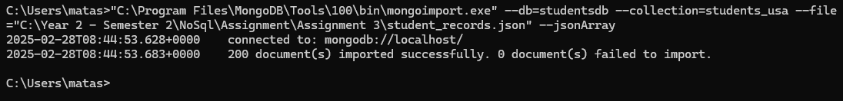

1. I listed out all cities located in the Southwest region that were distinct.

1. I found all adolescents under the age of 20, lived in a region that contained South, and have only 1 hobby. The initial performance of the query using explain() showed that it had works = 200 so it searched all 200 documents in the collection but once I created an index on region, age and hobbies it had works = 99 so it had to search less documents thus improving the query.

1. I found how many female students passed (grade>40) all 3 assessment components in each region

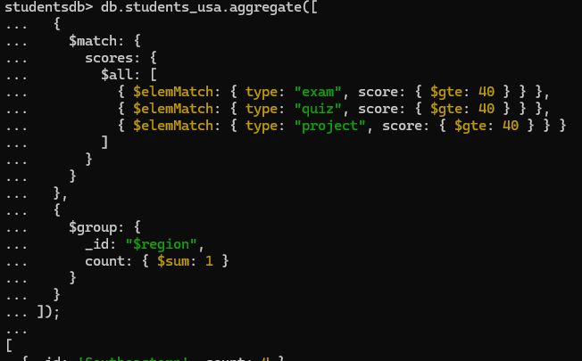

1. I found all students that passed all 3 assessment components in each class of each region.

1. I found the most popular hobby and the classes which had students with this hobby.

Part 3:

Mongo import statement and creation of database and collections.

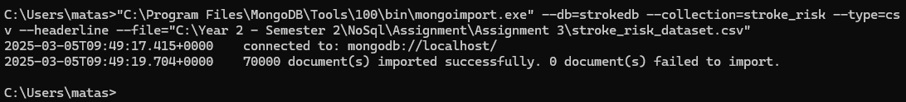

1. I created each view of patients who have cardiovascular symptoms, neurological symptoms and sleep-related issues with each view containing related symptoms.

1. I created the role for a cardiologist so they can view cardiovascular view and associated a user with this role then I found how many patients under the age of 30, who have chest pain, irregular heartbeats, high blood pressure and have over a 40% of getting a stroke. I used the cardiovascular view because the symptoms required in the conditions matched the cardiovascular view.

I found how many pensioners aged beteen 60 and 70, do not have risk of getting a stroke even though they fell dizzyness, fatigue and aches. I used the neurological view because the coditions required for the query matched those found in the neurological view.

1. I found how many patients age between 40 and 50 have over a 45% chance of not getting a stroke if they snore heavily. I chose the sleep-related issues view because the condition of snoring heavily matched the sleep-related issues view.

1. I found the chance of getting a stroke and age of a patient when they don’t have any anxiety when they participate in activities, feels constant discomfort in their chest, hand and feet are cold and is sometimes short of breath.

